
INN374 Assignment 2
Service-Oriented Architecture for Automotive Maintenance Activities


Student Number | Student Name
N8911371 | Chen-I Fang (Lester)
N9244255 | Manuel Brauer
N8964955 | Zahran AlAbri

Description of Automotive Maintenance Activities Service
Scope and basic functionality.

- Client application supports a GUI for customer requesting maintenance. It is written in Java using Swing and connects to the Sales Service.
- Sale Service is a SOAP web service provides methods for communication with customers and access the following web services. It is written in Java.
- Warehouse Service is a SOAP web service provides 8 methods to access the Warehouse Database server
- Supplier Service is a SOAP web service provides 6 methods to access the Supplier Database server
- Insurance Service is a SOAP web service provides the Sale service with the required details about a customer (implemented using WSDL)
- Garage Service is a SOAP web service provides the client with the appointment date after receiving a request from Sale service (implemented using WSDL)

Web-based Service Repository

Index HTML for all services
http://fastapps04.qut.edu.au/n8911371/index.html

Client:
provided in the zip file as runnable n9244255Client.jar

Sale Service:
http://fastapps04.qut.edu.au/n9244255/n9244255Sales.html

Warehouse Service:
http://fastapps04.qut.edu.au/n8911371/WebService/n8911371WarehouseService/WarehouseService.html

Supplier Service: http://fastapps04.qut.edu.au/n8911371/WebService/n8911371SupplierService/SupplierService.html

Insurance Service:
http://fastapps04.qut.edu.au/n8964955/n8964955_InsuranceWS.html

Garage Service:
http://fastapps04.qut.edu.au/n8964955/n8964955-GarageWS.html

Logical Layered Architecture
Public Service: Client
Process Centric Service : Insurance, Sales, Garage and Supplier
Basic Process (logic-centric) : Garage
Basic Process (data) : Warehouse

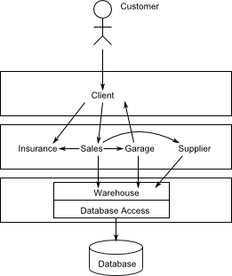

Level 1 Interaction Diagram
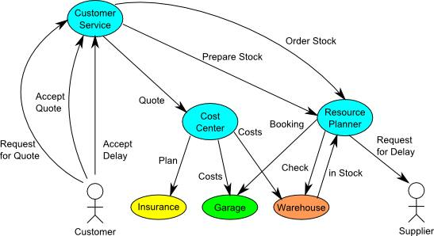

Choreography model

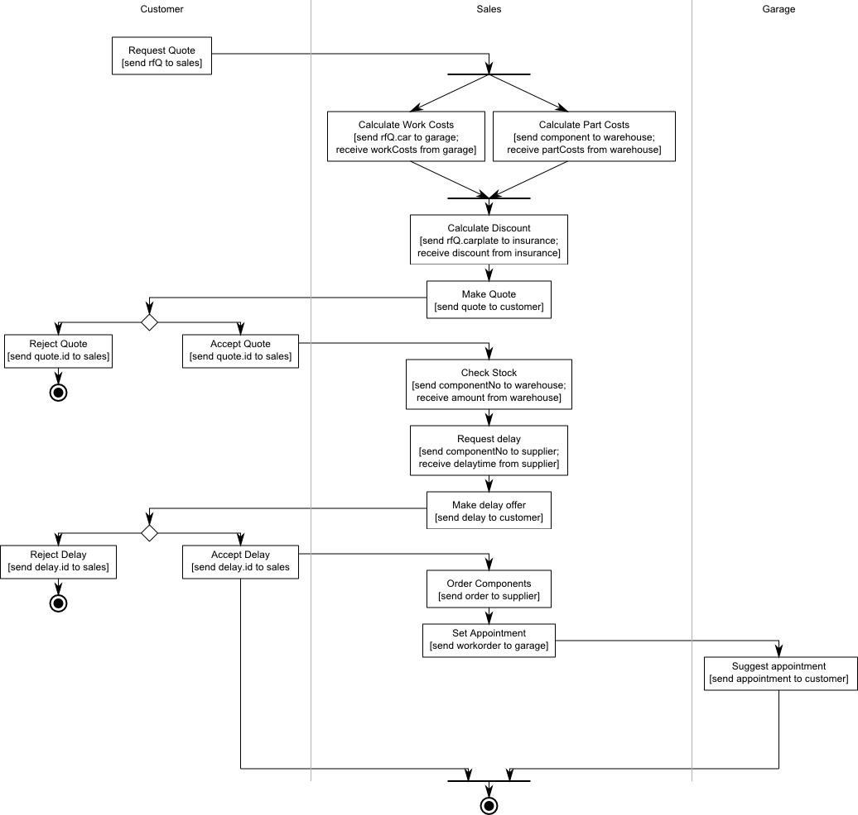
Orchestration model for process-centric service
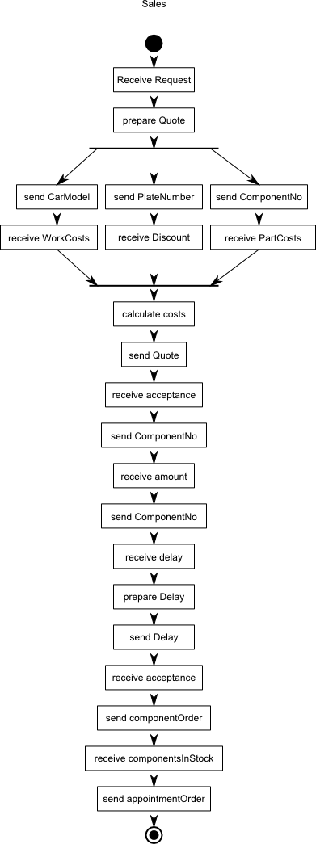
SOA analysis and design methodology

For Servicing Our Autos, we have decided to choose the top-down approach.

There are 2 reasons to explain
- The state is relatively stable, not often is changeable
- The scenario of Servicing Our Autos is followed by the top-down four step :
- 1st step: define the service scope: a company provides automotive maintenance activities for the clients.
- 2nd step: define who are the external actors: supplier
- 3rd step: define the reasons of the service to service and service to actor interactions：All software service should be exposed as web services.
- 4th step: details of services implementation：please read the table of service implementation

Why do we not use the bottom up approach and have 3 reasons?
- Do not integrate with partner processes because there is no partner processes.
- Do not need to meet the immediate requirements because we just follow the scenario of Servicing Our Autos.
- No legacy systems in this project

Assumption for our web services:

- Client
- Customer uses JVM

- Supplier
- We just consider to have only one supplier Database and one suppler.

- Warehouse
- We consider a small warehouse so we can have the ability to order the component for each time

- Sale
- Sales department knows which component is necessary to maintain the car.
- Do not check the client’s necessary elements: phone number, name and address

- Insurance
- Provide some default insurance records to use

- Garage
- The appointment day is no more than 30 days when the client accepts the delay day.
- Only can deal with known models for cost. If garage meets the unknown model, it can only get the default constant cost.
The aspects of service orientation

Client Application
- Front-End Application because it provides the software services for clients/sale department employees to use
- provides examples and allows self-made data for requests

Sale Web Service
- Process Centric Service because it handles the sale business process.
- Loose-coupling: only sale web service can handle the sale business process
- Abstraction: sale web service hide the inner sale process.

Warehouse Web Service
- Data Centre Service because it handles the warehouse database and encapsulates warehouse behavior.
- Loose-coupling: only warehouse web service can access the warehouse database to minimize dependencies with the warehouse database.
- Abstraction: warehouse web service hide the inner warehouse process.
- Reusability: the same reason with loose-coupling so it can promote reuse
- Composability: warehouse web service can coordinate supplier web service to increase the warehouse stock.

Supplier Web Service
- Data Centre Service because it handles the supplier database and encapsulates supplier behavior
- Loose-coupling: only supplier web service can access the supplier database to minimize dependencies with the supplier database.
- Abstraction: supplier web service hide the inner supplier process.
- Reusability: the same reason with loose-coupling so it can promote reuse
- Composability: supplier web service can coordinate warehouse web service to decrease the supplier stock.

Insurance Web Service
- Data Centre Service because it handles the insurance database and encapsulates insurance behavior.
- Loose-coupling: only insurance web service can access the insurance database to minimize dependencies with the insurance database.
- Abstraction: insurance web service hide the inner insurance process.
- Reusability: the same reason with loose-coupling so it can promote reuse

Garage Web Service
- Logic Centric Service because it encapsulates garage business rules.
- Loose-coupling: only garage web service can handle the garage business rules.
- Abstraction: garage web service hide the inner garage process.

Deployment Diagram
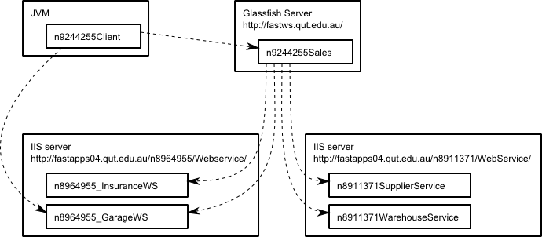

Service Implementation

Service Name | Platform | DB Server | Language | Technology | Lines of code | author
Supplier | Windows  with Microsoft IIS | MS SQL Server | C# | SOAP in WCF | 280 | Chen-I Fang
Warehouse | Windows  with Microsoft IIS | MS SQL Server | C# | SOAP in WCF | 314 | Chen-I Fang
Insurance | Windows  with Microsoft IIS | MS SQL Server | C# | SOAP in WCF | 66 | Zahran AlAbri
*Garage | Linux with Oracle Glassfish | None | Java | Restful in Java | 110 | Zahran AlAbri
Garage | Windows  with Microsoft IIS | None | C# | SOAP in WCF | 51 | Zahran AlAbri
Sale | Linux with Oracle Glassfish | MySQL  Server | Java | SOAP in JAX-WS | 650 | Manuel Brauer
Client | JVM | none | Java | SOAP in JAX-WS | 370 | Manuel Brauer

* The Java version of garage server has some troubles. One of the reasons is that the fastws server is easy to shut down the service led to be difficult to test the service. Therefore, we have decided to change another server, Windowswith Microsoft IIS.
Servicing Our Auto DB Table

Customer
Name | Type | Size | Primary Key | Default Value | Null | Example
CustomeName | Varchar | 30 | No | No | Not Null
plateNo | Varchar | 6 | Yes |  | Not Null, Unique
PhoneNumber | Varchar | 10 | No | No
Address | Varchar | 100 | No |  | Not Null
Model | Varchar | 100 | No |  | Not Null
Color | Varchar | 6

Insureance
Name | Type | Size | Primary Key | Default value | NULL | example
InsuranceID | Integer |  | Yes |  | Not Null
PlateNo | Varchar | 5 | Foreign key |  | Not Null | CFK06
Status | Varchar | 1 | No | N | Not Null | N : no insurance  F: full cover  P:partial cover
Discount | Integer | 10 | No | 0 | Not Null | 25.00%

Garage
Name | Type | Size | Primary Key | Default value | NULL | example
WorkOrderNo | Integer | 5 | Yes |  | Not Null | 10000
MechanicNo | Varchar | 5 | No |  | Not Null | 10000
Servicebay | integer | 10 | no |  | Not Null
Status | Varchar | 1 | No |  |  | W : waiting for customer
AppointmentDate | Date |  | No |  | Not Null

Supplier
Name | Type | Size | Primary Key | Default value | NULL | example
ComponentNo | Varchar | 5 | Yes |  | Not Null | 10000
ComponentName | Varchar | 30 | No |  | Not Null
Cost | Integer | 10 | No | 0 | Not Null
Amount | Integer | 10 | No | 0 | Not Null

Warehouse
Name | Type | Size | Primary Key | Default value | NULL | example
ComponentNo | Varchar | 5 | Yes |  | Not Null | 10000
ComponentName | Varchar | 30 | No |  | Not Null
Cost | Integer | 10 | No | 0 | Not Null
Amount | Integer | 10 | No | 0 | Not Null

PurchaseOrder
Name | Type | Size | Primary Key | Default value | NULL | example
PurchaseNo | Varchar | 5 | Yes |  | Not Null | 10000
TotalPrice | Integer | 10 | No |  | Not Null
delaytime | Integer |  | No |  | Not Null

PurchaseDetails
Name | Type | Size | Primary Key | Default value | NULL | example
ComponentNo | Varchar | 5 | Yes |  | Not Null | 10000
PurchaseNo | Integer | 10 | Yes  Foreign Key
Amount | Integer | 10 | No | 0 | Not Null
Price | Integer | 10 | No | 0 | Not Null

Test Client Service

This is the front-end application.
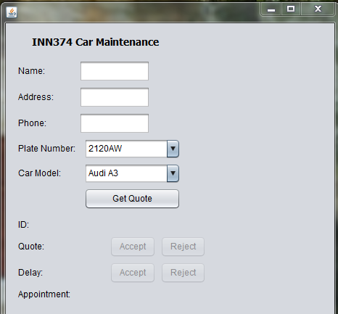

Case 1: Client accept and the warehouse database has no enough stock
This is the current warehouse database.
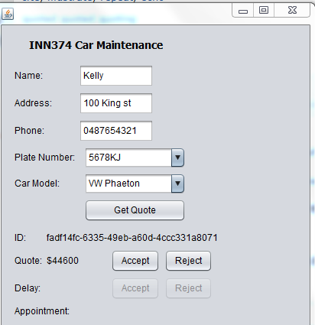

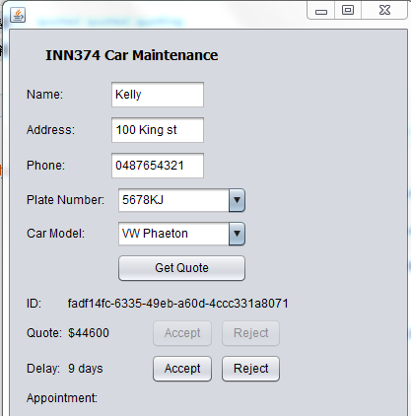
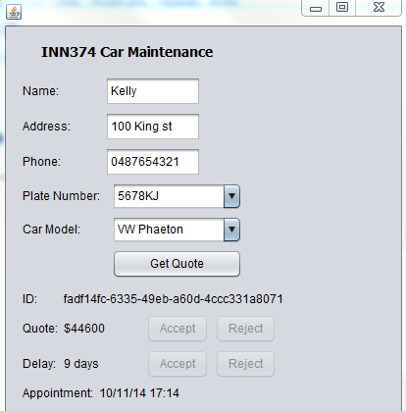

Case 2: Client accept and warehouse has enough stock
We have to update the warehouse database.
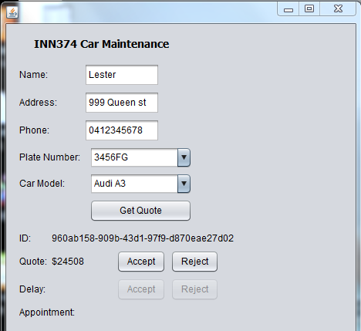

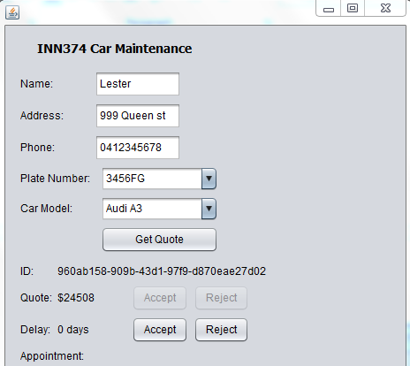

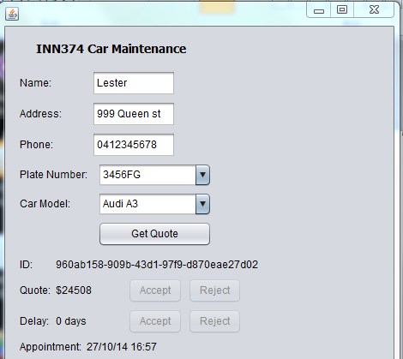
Case 3: Client reject at the quote situation.
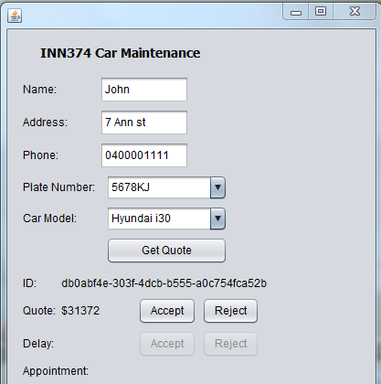

While clicking the reject button at the quote level, the front-end application will clear up ID and quote record.
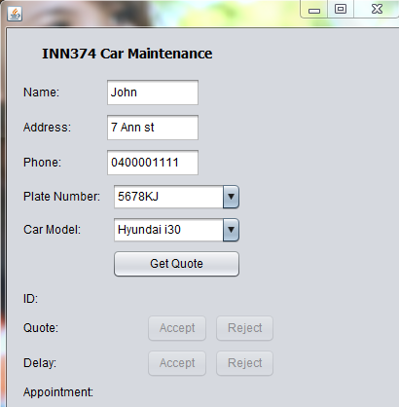
Case 4: Client reject at the delay time situation.
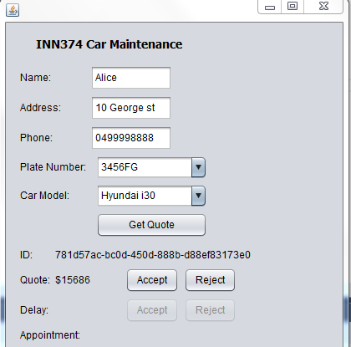

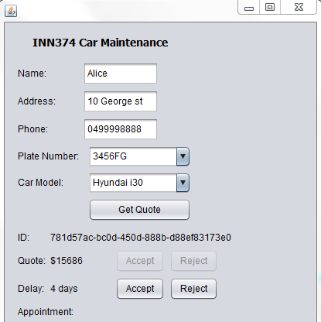

While clicking the reject button at the delay time level, the front-end application will clear up ID, quote and delay record.
